**LAB # 04**

**SUPERVISED LEARNING (NAÏVE BAYES ALGORITHM)**

**OBJECTIVE**

Implementing supervised learning, Naïve Bayes algorithm for training, testing and classification.

**Lab Tasks:**

**Weather Temperature Play**

#### 

1. Implement Naïve Bayes Algorithm on the above dataset in Fig 1 to predict whether the players can play or not when the weather is overcast and the temperature is mild.

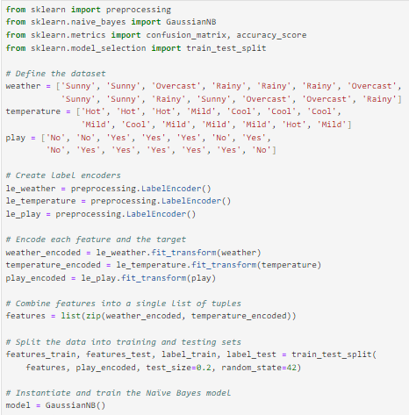

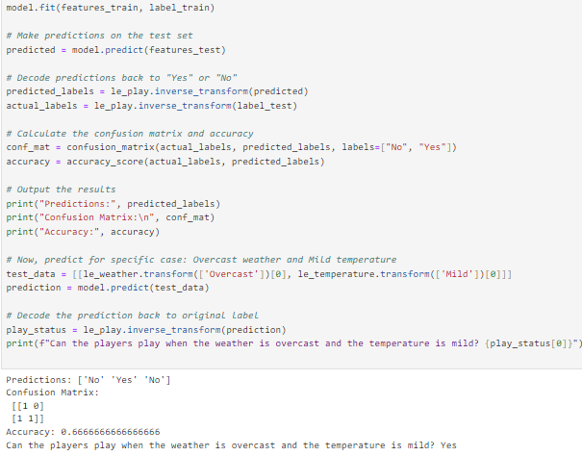



1. Consider the following dataset. Implement Naïve Bayes Algorithm to classify youth/medium/yes/fair**.**

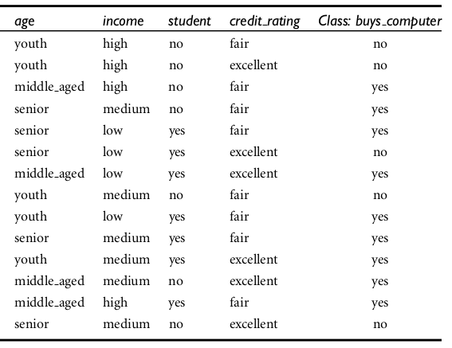

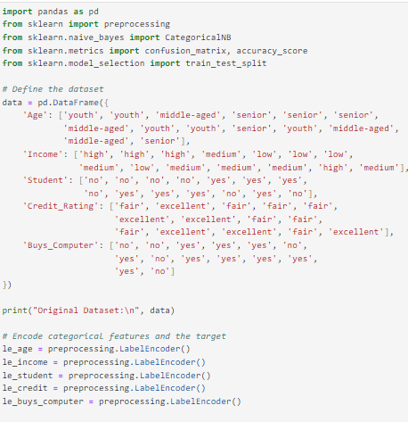

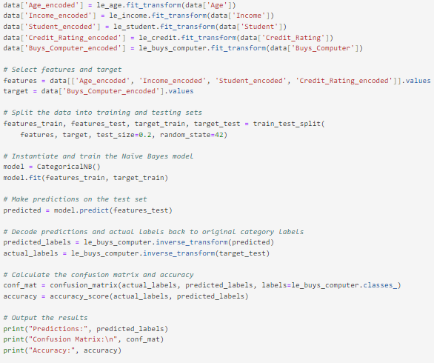

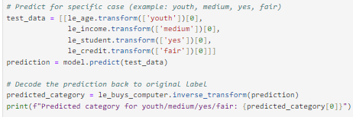

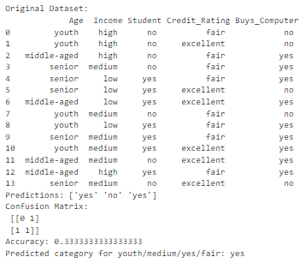

**Home Assignment:**

The objective of the provided code is to classify students' passing status using a Naïve Bayes algorithm based on their gender, age, and math score. This code demonstrates the application of supervised learning to train, test, and predict student performance, aiding in identifying those who may need further academic support or intervention.

* Gender: Represents the student's gender, categorized as 'Female' or 'Male'.
* Age: Indicates the age of the student in years.
* Math Score: The student's score in mathematics (0-100 scale), reflecting math proficiency.
* Passing Status: Indicates whether the student has passed ('Yes') or failed ('No'); this is the target variable for prediction.

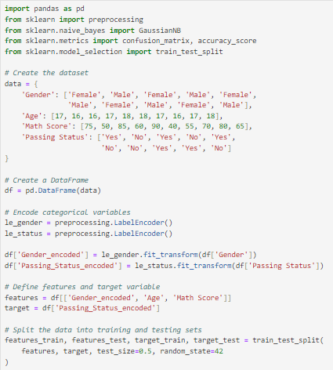

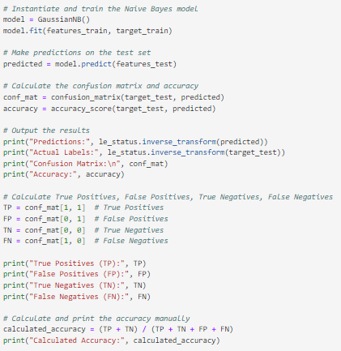

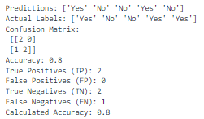

* **Files Uploaded On Github:**